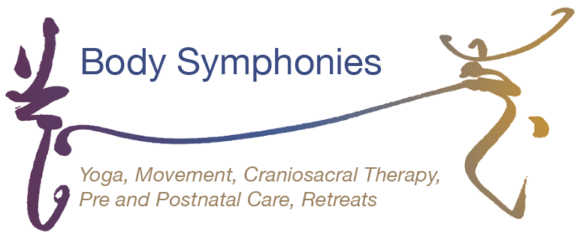

Full name
Address incl. postcode

Date of birth
Contact phone number(s)
Email address
Please state which course you are registering for e.g. teacher training/ retreat

In this section, tell us about your experience of yoga, about your practice and why you want to take part in the training.

Health and medical information
Please describe here any medical information or health conditions, both existing and prior, that may be relevant, or that may affect your ability to take part in the training.
Include any surgery you have had in the last two years, and any medication that you take.
Allergies.

Are you pregnant or have you given birth in the past year?

Emergency Contact Details
Give details of who you would like us to contact in case of emergency
Name
Address

Phone no
Email
Relationship to you

Signature |  | Date
If you return this form by email, we will accept a typed name as your signature

Annamaria Sacco | info@bodysymphonies.co.uk | Tel: +44 (0)7818 553 788
Body Symphonies, 6.11 St Margaret’s House, 151 London Rd, Edinburgh EH7 6AE

